Post COVID-19 Patient Information Booklet

Helping you to recover and manage your symptoms following COVID-19

## What is Coronavirus (COVID-19)?

COVID-19 is a highly contagious virus that mainly attacks the lungs. It is transmitted through droplets created from sneezing and coughing from those infected. The virus enters the body via the nose, mouth and eyes.

The most commonly reported symptoms of COVID-19 are:

* a new continuous cough
* a fever
* change to appetite/taste/smell
* fatigue
* Pain
* shortness of breath when moving around
* To manage mild symptoms:
* stay hydrated
* take paracetamol if you have a temperature
* rest
* get up and move about at regular intervals

To manage mild symptoms:

* stay hydrated
* take paracetamol if you have a temperature
* rest
* get up and move about at regular intervals

The severity and duration of symptoms for people who have COVID-19 can vary. For most people, symptoms last 7-14 days and will be very mild. If you need additional advice, visit the NHS 111 online service

## What do I do if my symptoms get worse?

Monitor your symptoms regularly. If you get one of the following:

* Worsening shortness of breath
* A new or returning fever
* Worsening ability to concentrate
* Chest pain

Please call 111 for more advice or for a medical emergency or dial 999 immediately.

## Who is at risk?

The severity of the initial illness does not indicate whether you will go on to develop Long Covid (or its severity).

## How might I feel after having COVID-19?

The length of time that it takes to recover from COVID-19 varies from person to person, for some it will be days, others weeks or months. The more severe your symptoms, the longer it might take for you to return to what is normal for you.

Symptoms include:

* Poor Sleep
* Changes to mental health e.g Anxiety, Depression etc
* Fatigue
* Breathlessness and/or Cough
* Muscle weakness/fatigue
* Pain (aching, pins and needles, burning)
* Brain Fog; poor concentration, Memory etc
* Sensory overload
* Changes to toileting habits
* New food intolerances
* Difficulty returning to work/education

This might make it more difficult to do the things you are normally able to do, such as housework, having a wash, getting dressed or walking up and down the stairs.

## Ways to help you manage your symptoms

**Breathlessness management**:

* Being breathless can be a symptom of Long Covid
* The way we breathe can change and become less efficient
* You may be breathing quicker and shallower than normal
* Breathlessness can continue due to deconditioning and anxiety

**Breathing control:**

* Get in a comfortable position (see pictures).
* 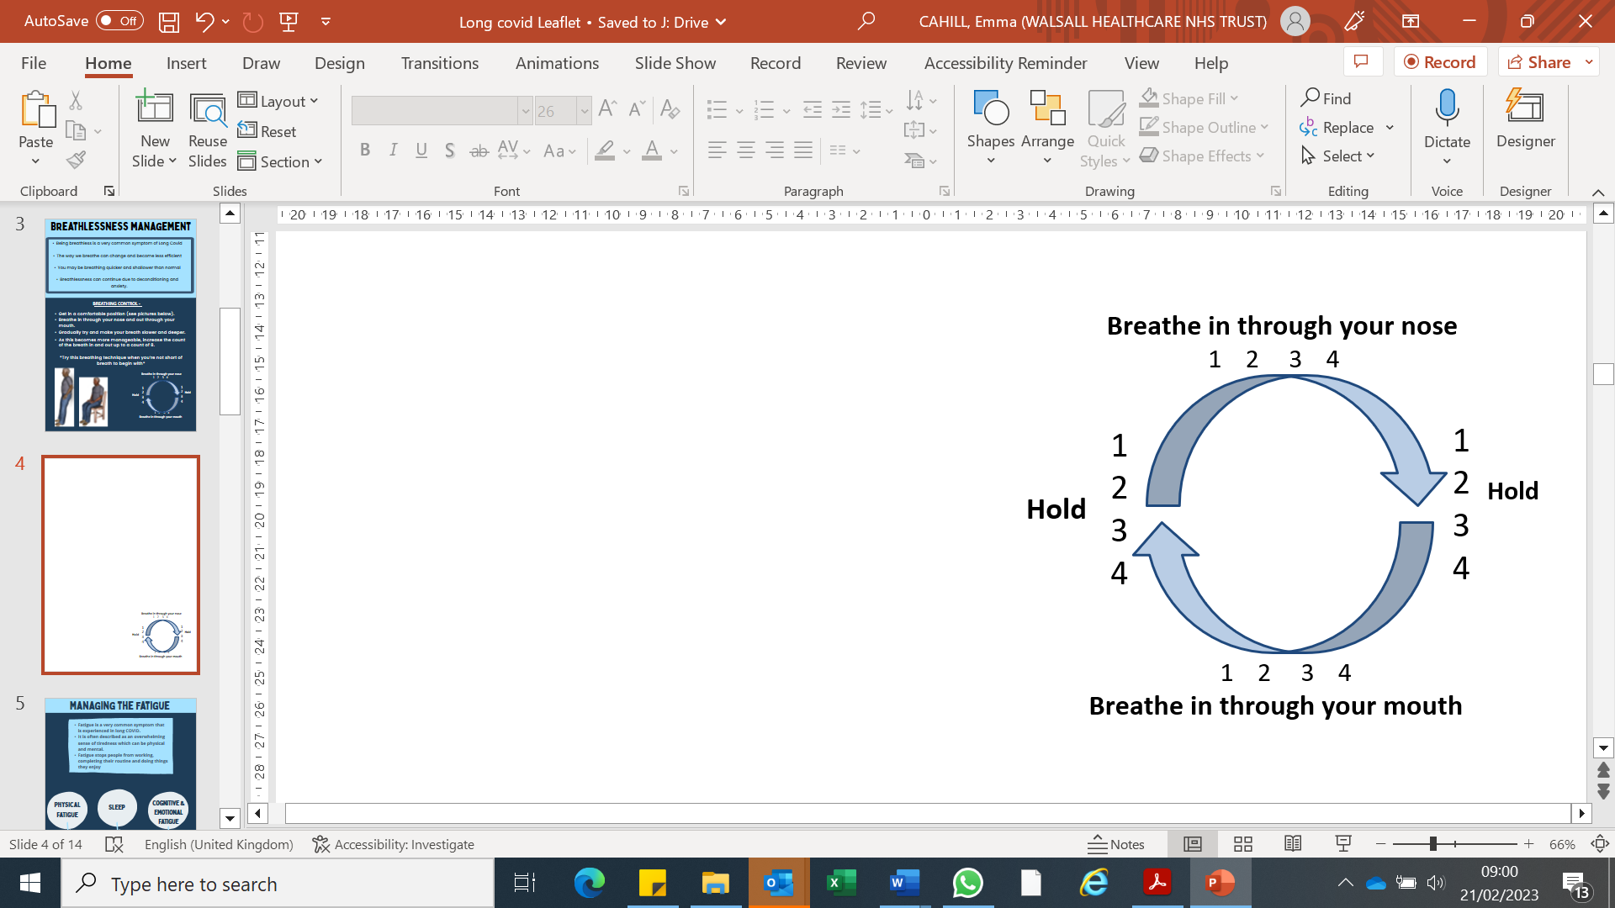Breathe in through your nose and out through your mouth.
* Gradually try and make your breath slower and deeper.
* As this becomes more manageable, increase the count of the breath in and out up to a count of 8 (you can start of with 4 and build up).

Try this breathing technique when you’re not short of breath to begin with.

If you are struggling with Phlegm, ask your Health care professional how to best manage this.

**Managing your Cough:**

* Stay hydrated - take small sips, one after the other, avoid taking large sips
* Drink warm honey and lemon or another warm drink, this can help to soothe the throat
* Steam inhalation – pour hot water into a bowl and put your head over the bowl. If comfortable, cover your head and bowl with a towel

## Fatigue Management

* Fatigue is a very common symptom that is experienced in Long COVID
* It is often described as an overwhelming sense of tiredness which can be physical, cognitive or emotional
* Fatigue impacts people working, completing their routine and doing things they enjoy
* Good and bad days are normal
* Often people do too much on days they feel better, which then has a detrimental impact for the day(s) to come, ‘Boom and Bust' is used to describe this process
* The aim is for a more gradual and consistent recovery using the 3’s

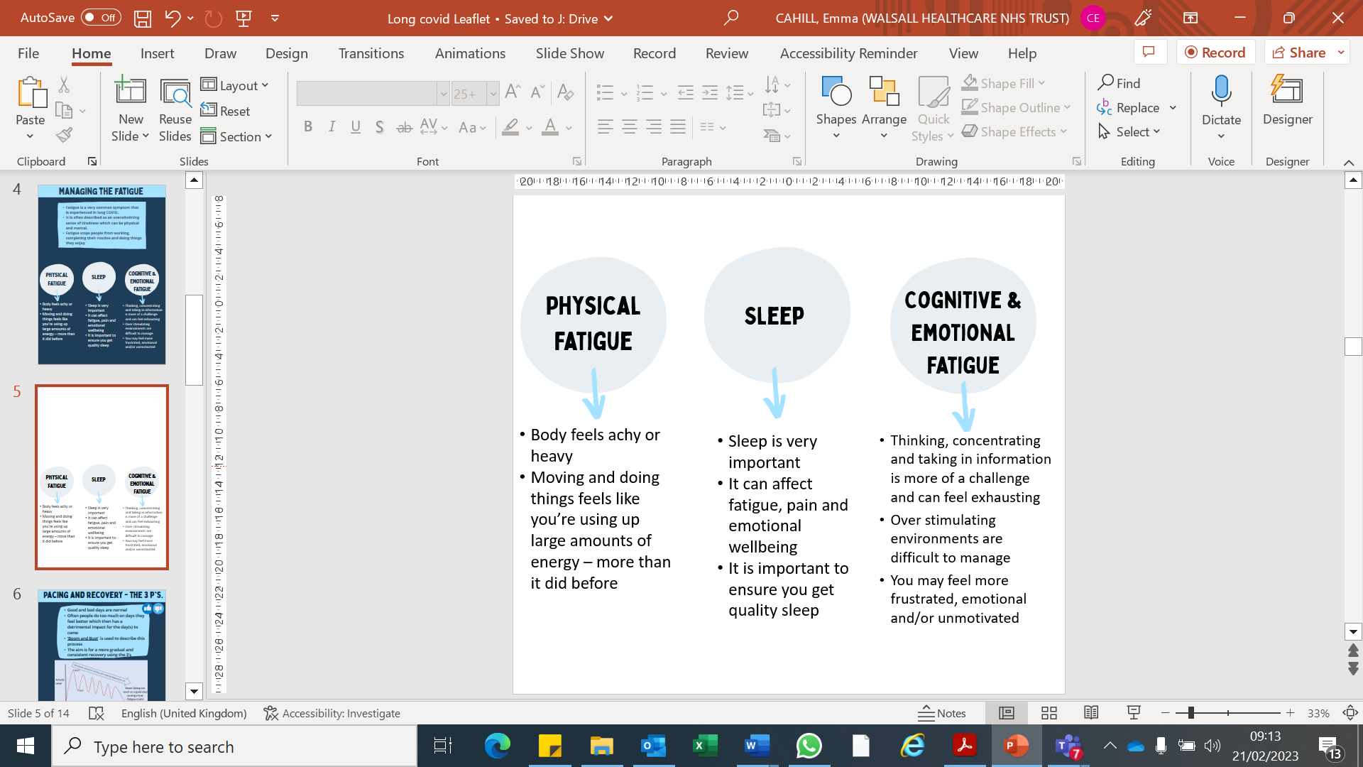

**Physical fatigue**

* body feels achy or heavy
* Moving and doing things feel like you’re using up large amounts of energy – more than it did before

**Sleep**

* Sleep is very important
* It can affect fatigue, pain and emotional wellbeing
* It is important to ensure you get quality sleep

**Cognitive and emotional fatigue**

* Thinking, concentrating and taking in information is more of a challenge and can feel exhausting
* Over stimulating environments are difficult to manage
* You may feel more frustrated, emotional and/or unmotivated

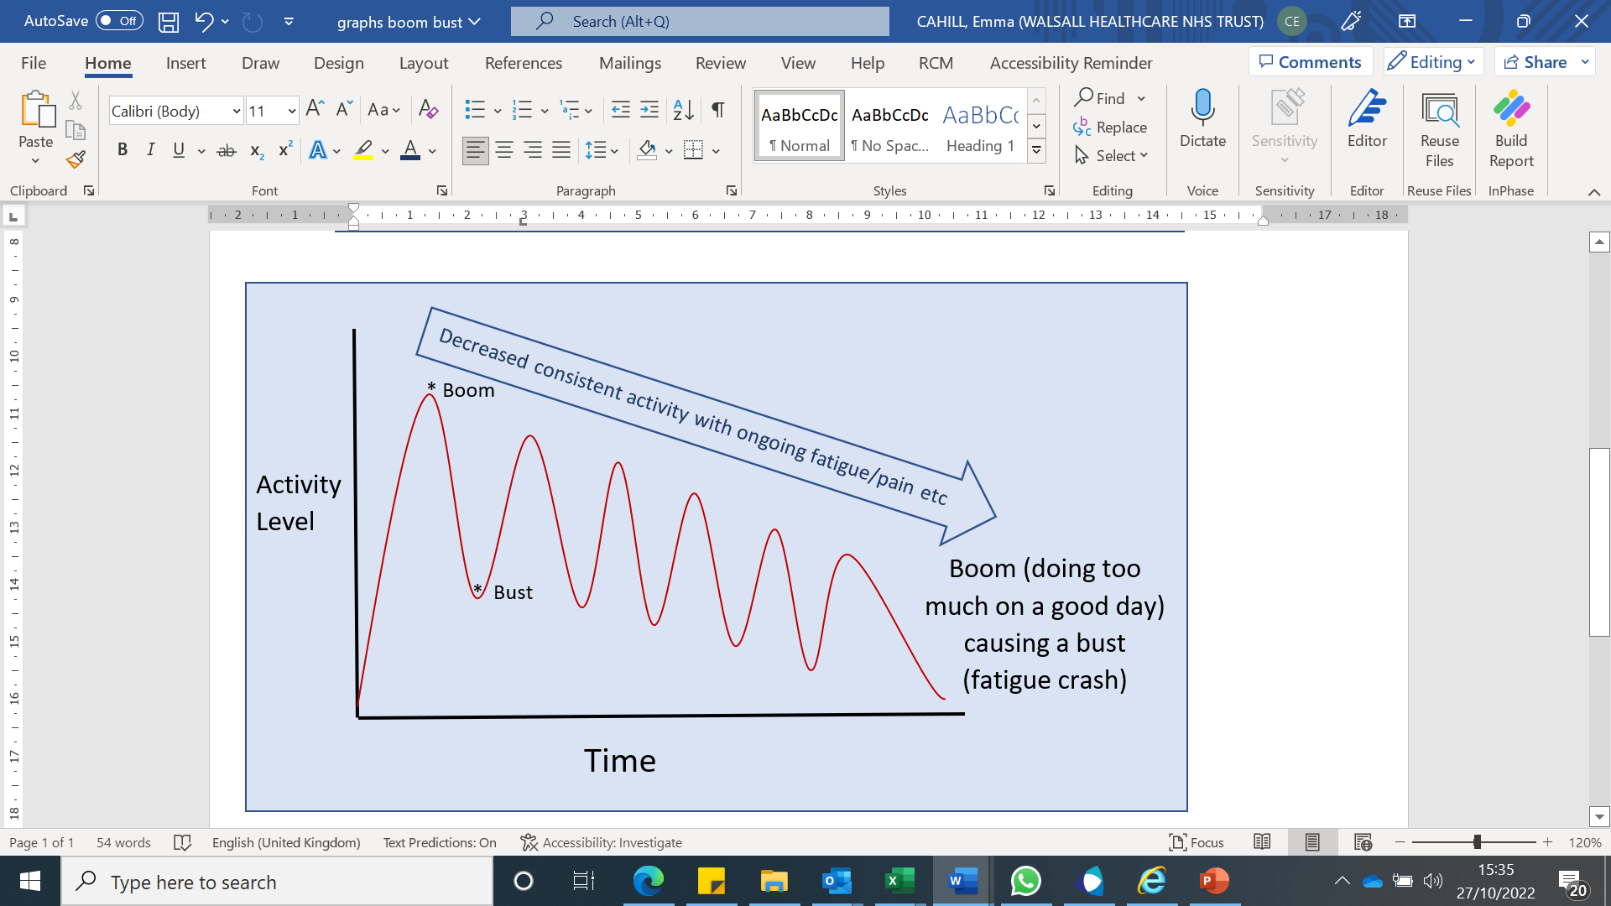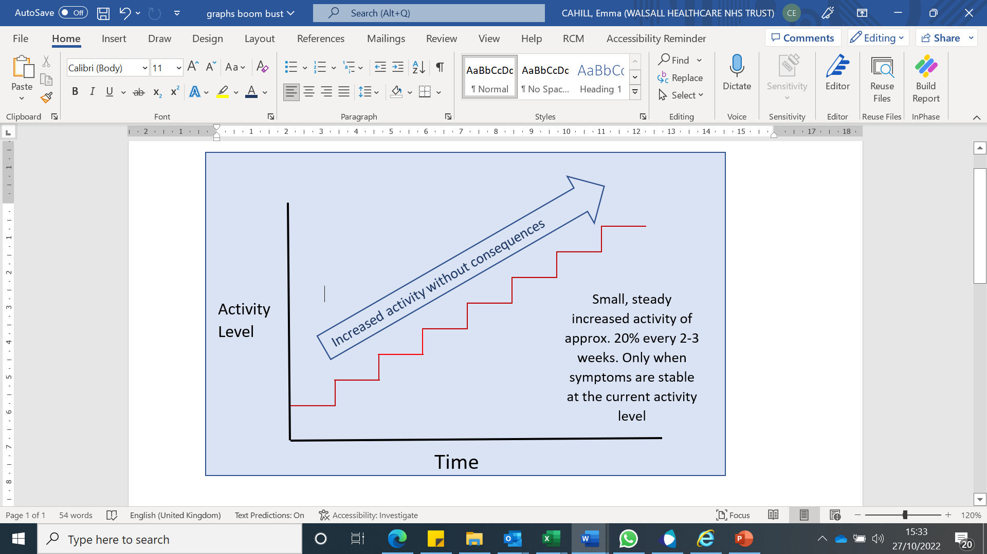

Use the ‘3 Ps’ to help manage fatigue and avoid a Boom and Bust:

**Prioritise**

* It may be helpful to identify things that **NEED** to be done
* Things you **WANT** to do can be left for another day/time
* Ask others to help
* Tip - write down things you **need** to do and things you **want** to do throughout the week
* Try scoring them to help you prioritize.

**Plan**

* Gather all the items you will require for the task
* Think about how you can break the task down in small sections
* Think about the time you are at your best to complete the activity
* Plan the activity on a day you have support around you
* It's equally as important to plan time to recharge.

**Pace**

* Pacing can help you get out of the boom and bust cycle
* Allow enough time
* Rest regularly
* Sit and rest where you can
* Use equipment to help
* Don’t compare yourself to others or what you could do before
* Increase your activity levels approx. every 2 weeks by 20% - as long as the previous level was manageable.

## Emotional Support

The effects of having COVID-19 can be very unsettling. It is very understandable that the experience may have an emotional impact.

Whether you have had mild or more severe symptoms, these are some common difficulties that you may be having:

* Feeling anxious
* Worries about health or about family or friends getting ill
* Feeling low in mood
* Poor sleep
* Money / housing / employment worries

**What can help?**

* Speak to family and friends
* Try to do activities that you find enjoyable and relaxing
* Don’t be too hard on yourself if there are some things that you are finding harder to do, remind yourself that recovery takes time
* Focus on what is in your control like eating well

If you continue to feel overwhelmed by your symptoms speak to your GP or a member of the Long Covid Team

Alternatively, you can call theBlack Country Mental Health Support line on **0800 008 6516**. The line is open 24 hours a day, seven days a week.

## Additional Tips

**Hair Loss**

* Many people find their hair becomes very thin and/or falls out more than before they were unwell
* Some evidence suggests that taking a Zinc Supplement can aid with preventing and improving this

**Gluten intolerance**

* New intolerances to food is common post Covid – especially gluten (bread, pasta, biscuits, sauces, crisps etc)
* You may find your feel bloated, uncomfortable, stomach cramps, Diarrhea, Constipation, feeling lethargic, achy
* It may be helpful to complete a food diary and monitor which foods make you feel this way.
* If you identify certain foods make you feel unwell, remove them from your diet to see if your symptoms improve.

**Eyesight**

* A percentage of people report their eyesight has changed since Covid
* This can cause a change in your prescription or needing to have glasses if you didn’t already.
* If you are finding your vision is more strained, or your get more frequent headaches, it is advised to have your eyes tested at an Opticians.

**Hearing**

* Many people report a change to their hearing or change to understanding people noise/ people speaking.
* It may be difficult to filter sound in a busy environment or with background noise – we can help you manage this.
* Some people complain of buzzing/tinnitus.
* It is a good idea to get your hearing checked to rule out an Auditory issue

**Toileting**

* You may find that your need to go to the toilet more often, feel as if you haven’t emptied your bladder fully, or sometimes not get to the toilet in time
* This again is common and support can be provided to help manage this.

**Work**

* Return to work may be an important aspect that we discuss with you. Often when returning to work people benefit from a phased return which can include a temporary reduction in hours and/or days worked, amended duties and awareness of aggravating factors
* You may benefit from occupational health input or other support to return to work
* Working from home can be helpful for some people but for some can make them feel more isolated and can negatively impact mental health.

**Sleep**

* Sleep is incredibly important.
* Poor sleep can impact your memory, mood/emotion, pain and general function.
* Long Covid can affect sleep by increased pain, worrying, increased toileting etc.
* Sleep hygiene can help to get increased quantity and quality of sleep; e.g. having a schedule and routine, avoid caffeine after 5pm, don’t eat late, keep your bedroom a calm and inviting environment, try calming music/sounds, limit screen time 30min before bed.
* We can help you find ways to good quality sleep.

**Pain**

* The type of pain you experience helps us to work out what the problem is. This can be muscular pain, joint pain or nerve pain
* Neuropathic pain is described as burning, tingling or pins and needles which often effects our hands and/or feet
* Hypersensitivity or allodynia is when the signals to the brain are misinterpreted as pain. This can make even light touch or everyday tasks painful
  + The correct medication and exercise are two ways which pain can be improved.

**Vagus nerve**

The vagus nerve is the longest nerve of the autonomic nervous system and is one of the most important nerves in the body.

It helps regulate many critical aspects of human physiology, including the heart rate, blood pressure, sweating, digestion, and even speaking.

After Covid sometimes the Vagus nerve doesn’t work as efficiently, but there are some easy ways to improve this:

* Yoga and Meditation
* Tai Chi
* Having a cold shower/splashing face with cold water
* Drinking a cold drink/eating cold things e.g Ice Lollies
* Gargling
* Deep Breathing exercises
* Singing or Humming



## Post COVID Support Services

Below are a range of local services and useful links that can offer advice and support should you need it:

**Self Care Management Team**

The Self Care Management Team provide different programmes to help you learn techniques and skills to cope and manage with your symptoms (both of your own health condition or those of someone you care for).  The Long Covid Self care management programme includes:

Information on how to manage specific symptoms of a Long Covid condition with emphasis on skills to better cope with fatigue and pain, anxiety and low mood and includes breathing techniques and relaxation exercises.  The course also looks at how individuals who feel isolated with this condition, can talk to others who have experienced the same and who understand, so that you no longer feel alone.

The Self Care Management team also offer additional courses on Diabetes, Chronic Pain and for Caring for people with a long term medical condition/disability. All of these NHS courses are free and consist of 6 weekly sessions each lasting two and a half hours.

If you are interested in attending the course then please contact the Self Care Management Team on **01922 605490** or email [selfcare@walsallhealthcare.nhs.uk](mailto:selfcare@walsallhealthcare.nhs.uk).

**Supporting your recovery after COVID-19**

As you find yourself recovering from COVID-19 you may still be coming to terms with the impact the virus has had on both your body and mind. These changes should get better over time, some may take longer than others, but there are things you can do to help.

Visit the Your COVID Recovery website <https://www.yourcovidrecovery.nhs.uk/> to help you to understand what has happened and what you might expect as part of your recovery.

**Walsall Community Living Directory**

This provides an easy to search comprehensive directory of clubs, community, third sector and voluntary organisations, care providers, self-help groups and what's on listing of local events. Individuals can search information under the key headings including money matters, housing, health and well-being and education and employment. You can access the website here: <https://www.wcld.co.uk>

**Making Connections Walsall**

Making Connections Walsall is a friendly service for people in Walsall that aims to address loneliness and social isolation and other issues you may be facing.

There are lots of groups, organisations and clubs in Walsall which can support the health and well-being of local people and Making Connections can help you identify not only activities, but projects and services available in your community to support you.

It is open to all Walsall residents of all ages.

Call **0121 380 6690 to self refer** and you will be contacted by your local hub within 3 working days.

You can also be referred by your GP/Healthcare professional and social care professional

**Citizens Advice Sandwell and Walsall**

Citizens Advice Sandwell and Walsall provides free, confidential and impartial advice for the problems people in Sandwell and Walsall may have.

This includes general advice as well as debt, housing, benefits and work related advice and support.

Call **0808 278 7812** or visit <https://citizensadvicesandwell-walsall.org/> for more information.

**Walsall Talking Therapies Service**

Our Walsall Talking Therapies Service supports people with depression and anxiety symptoms. We can help people aged 17 and over who are registered with a Walsall GP.

You can self-refer by calling **0800 953 0995** or visit [www.blackcountryhealthcare.nhs.uk/our-services/talking-therapies-healthy-minds-services/walsall-talking-therapies](http://www.blackcountryhealthcare.nhs.uk/our-services/talking-therapies-healthy-minds-services/walsall-talking-therapies) to refer online or find out more about the service.

**Black Country Mental Health Support**

If you are experiencing increased distress or anxiety during these uncertain times, please don't suffer in silence, pick up the phone and speak to one of our specialist mental health professionals who will be able to support you.

Call the support phone line on **0800 008 6516** 24 hours a day, seven days a week.

Or Text message service on **07860 025 281**

**Stop Smoking Services**

The Stop Smoking Service is delivered by a qualified stop smoking advisor over 6 weeks, provides support to help deal with the day to day challenges associated with stopping smoking for example cravings as well as medication support.

To contact Walsall stop smoking services call **01922 444044.**

For more information visit:[https://www.oneyouwalsall.com/stop-smoking/](https://gbr01.safelinks.protection.outlook.com/?url=https%3A%2F%2Fwww.oneyouwalsall.com%2Fstop-smoking%2F&data=05%7C01%7Cemma.cahill%40nhs.net%7C4e7d7337aaa74bec765708db68d6fd02%7C37c354b285b047f5b22207b48d774ee3%7C0%7C0%7C638219044787480593%7CUnknown%7CTWFpbGZsb3d8eyJWIjoiMC4wLjAwMDAiLCJQIjoiV2luMzIiLCJBTiI6Ik1haWwiLCJXVCI6Mn0%3D%7C3000%7C%7C%7C&sdata=NgNgTt1Xn4IQYZ%2FJGe%2Fg2duoavBP4uwKRgLk6C9JrCU%3D&reserved=0)

**Covid updates**

You can get all the latest COVID Updates from Walsall Council by visiting <https://go.walsall.gov.uk/covid-19_information>

If you require this information in an alternative language or format please contact us on **01922 605947.**

The Walsall Together Place Based Partnership would like to acknowledge and thank NHS Homerton University Hospital NHS Trust for kindly allowing us to replicate and localise their Post COVID Patient Information Pack for the people of Walsall.

**Walsall Long COVID service**

The Long COVID service has an answerphone that can be used as a contact for the team if you want to be re-referred to the service or related enquiries. 01922 604971.